Database for Product Service:

ERD:

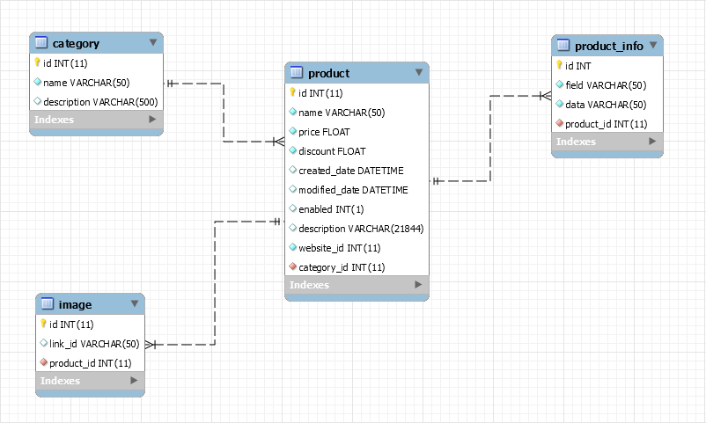

Table ‘**product**’:

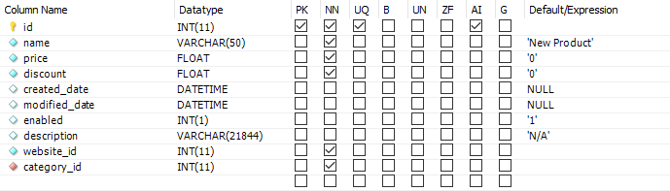

* **id** (int – auto increment): ID of the Product.
* **name** (varchar): name of the Product.
* **price** (float): price of the Product.
* **discount** (float): the discounted amount of the Product, store **DECIMAL NUMBER** (e.g. **0.5** instead of 50%).
* **created_date** (datetime): Product’s created date, use **TimeStamp** in code.
* **modified_date** (datetime): Product’s latest modified date – null by default, use **TimeStamp** in code.
* **enabled** (int):
  + - 1 (default): Product is **enabled.**
    - 0: Product is **disabled.**
* **description** (varchar).
* **website_id** (int): ID of the Website that this Product belongs to.
* **category_id** (int): ID of the Category of this Product.

**Edit**:

* Added new column ‘**producer**’ (varchar): Producer of the Product.

Table ‘**category**’:

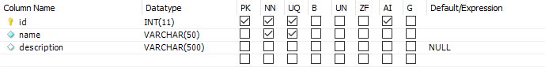

* **id** (int – auto increment): ID of the Category.
* **name** (varchar): name of the Category.
* **description** (varchar).

Table ‘**image**’:

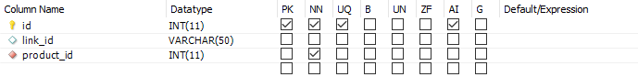

* **id** (int – auto increment): ID of the Image.
* **link_id** (varchar): ID of the Image stored on Google, Amazon… from its URL.
* **product_id** (int): ID of the Product that this Image belongs to.

Table ‘**product_info**’ (optional):

Example:



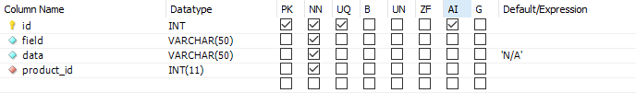

* **id** (int – auto increment): ID of the Field – Product’s info.
* **field** (varchar): name of the Field (e.g. ‘Nhà sản xuất’, ‘Bảo hành’).
* **data** (varchar): data of the Field (e.g. ’GYGABYTE’, ’36 tháng’).
* **product_id** (int): ID of the Product that this Field belongs to.